Exit Pass Week 4
Question 1:
Raj has $182 in his bank account.
- Represent this amount as a positive integer.

- Raj withdraws $200 from his account. Write a subtraction problem that helps you calculate the new account balance.

- What is his new account balance as an integer?

- Does Raj have money in his account or does he owe money to the bank?

Question 2:
At Thredbo, the daily maximum and minimum temperatures were recorded over a week.
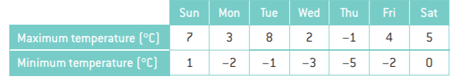
- Calculate the difference between the minimum and maximum temperatures for Sunday. (Hint: subtract the minimum temperature from the maximum temperature.)

- Calculate the difference between the minimum and maximum temperatures for Monday.

- Calculate the difference between the minimum and maximum temperatures for each of the remaining days.

- Which day had the biggest range of temperatures?

ANSWERS:

1 a 6°C b 5°C c Tue 9°C, Wed 5°C, Thu 4°C, Fri 6°C, Sat 5°C d Tue

2 a +182 b (+182) – (+200) or 182 – 200 c –18 d Raj owes $18.

